**Setting Up Jenkins Pipeline to Deploy Docker Swarm**

**Project objective:**

You have to develop an environment for Docker networking.

As you have worked on Docker containers previously, your manager has asked you to perform container scheduling over multiple hosts using Docker CLI and connect multiple hosts with Docker containers.

**You must use the following:**

● Jenkins: To create a pipeline to deploy Docker Swarm  
● Docker Swarm: To implement container networking  
● Git: To connect and push files from the local system to GitHub   
● GitHub: To store the Angular application

**Following requirements should be met:**

● A few of the source code should be tracked on GitHub repositories. You need to document the tracked files that are ignored during the final push to the GitHub repository.  
● Submission of your GitHub repository link is mandatory. In order to track your task, you need to share the link of the repository in the document.  
● The step-by-step process involved in completing this task should be documented.

**Screenshots:-**

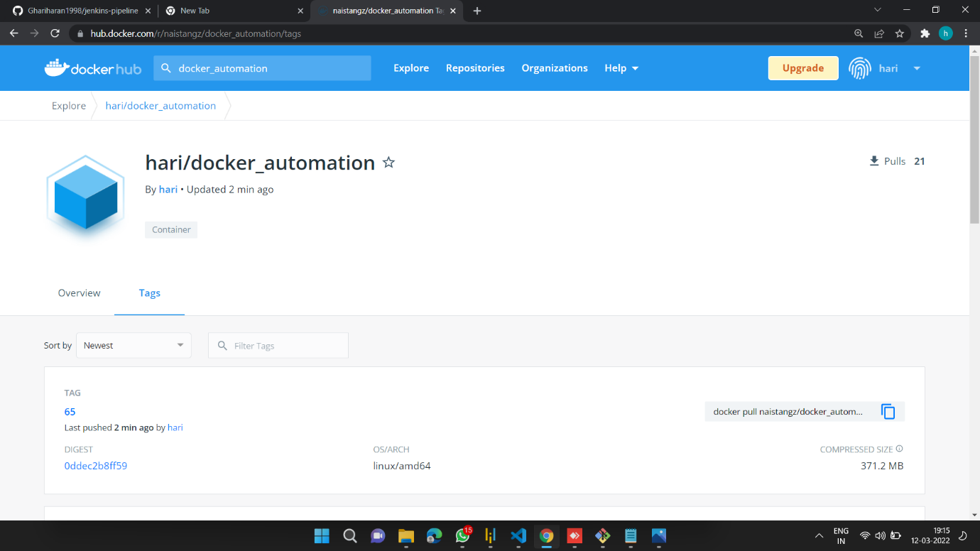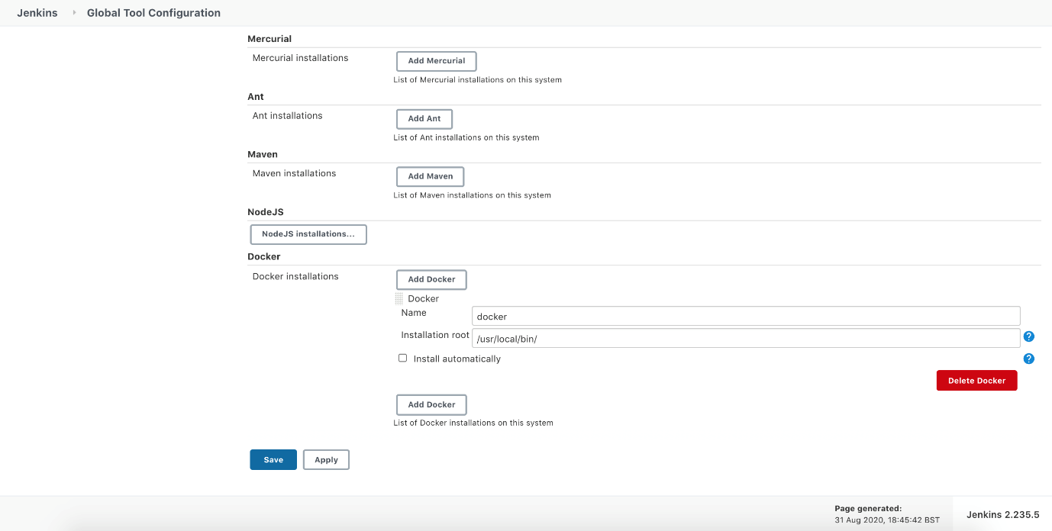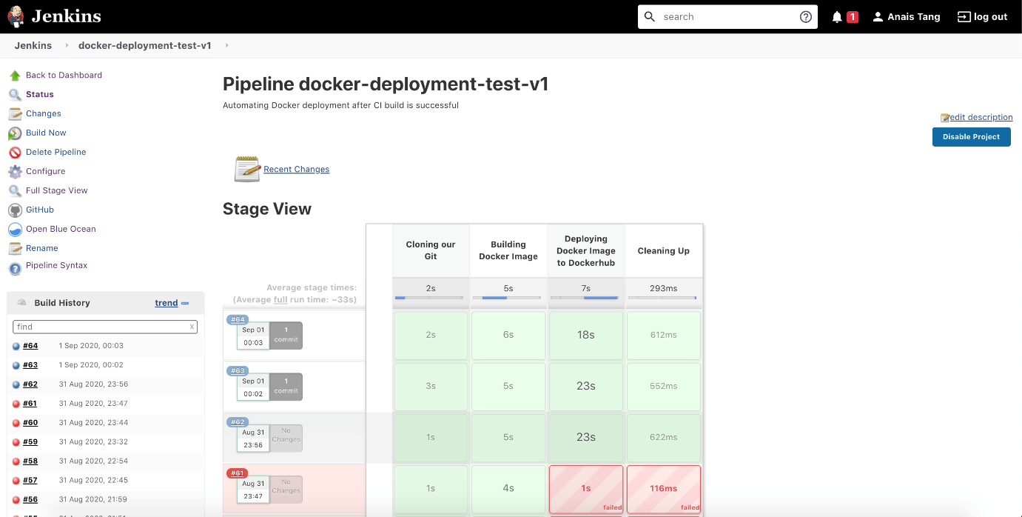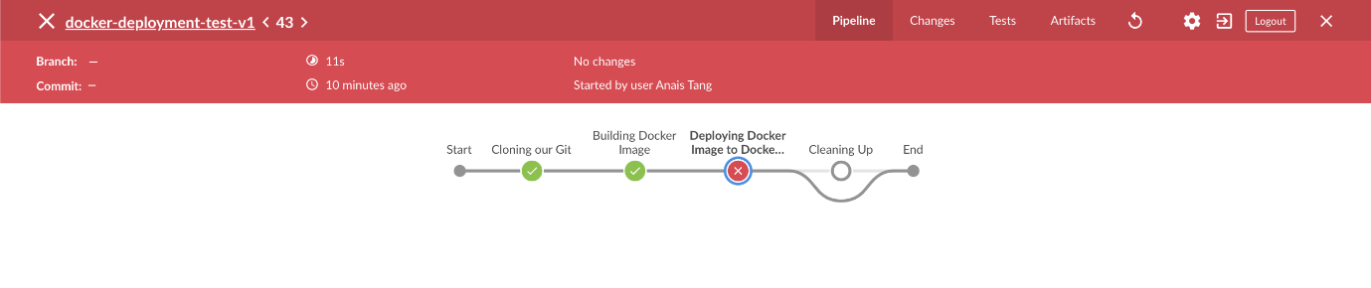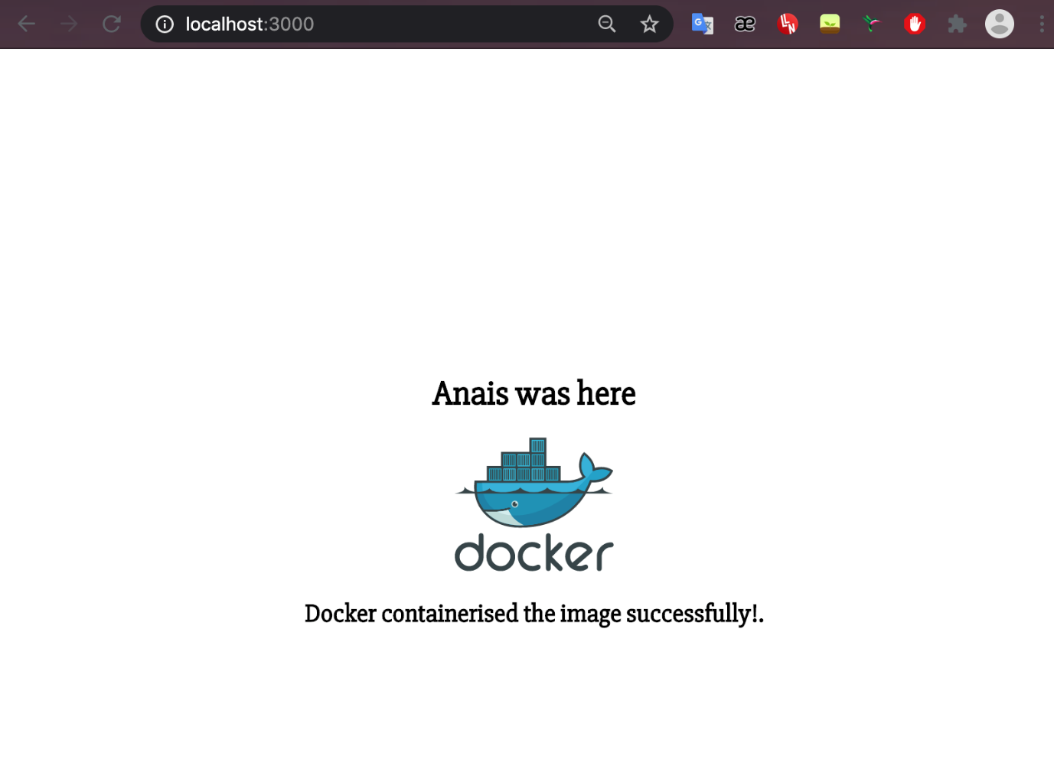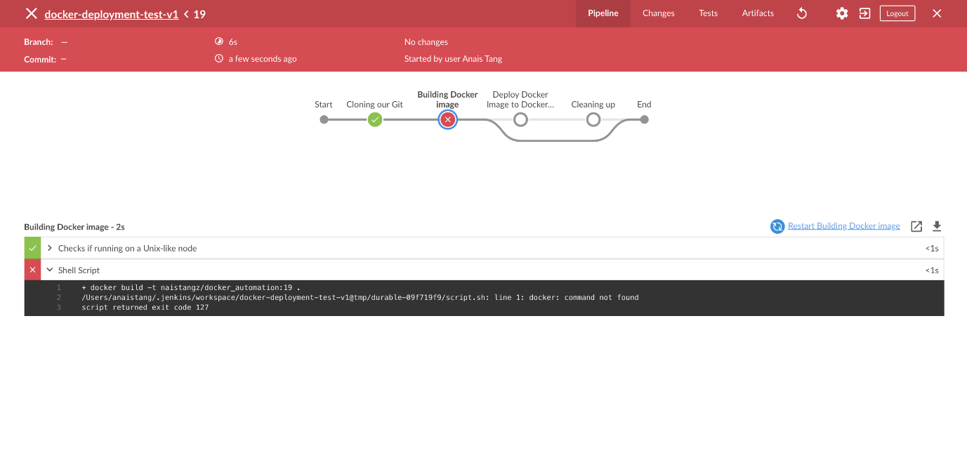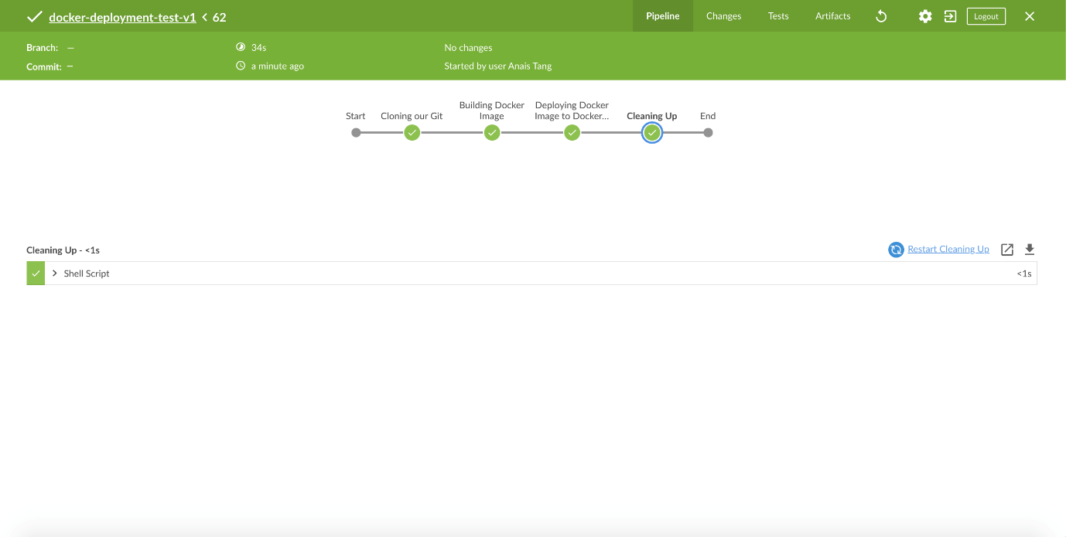

## **Pushing the code to GitHub repository:-**

* Open your command prompt and navigate to the folder where you have created your files.

**cd <folder path>**

* Initialize repository using the following command:

**git init**

* Add all the files to your git repository using the following command:

**git add .**

* Commit the changes using the following command:

**git commit . -m <commit message>**

* Push the files to the folder you initially created using the following command:

**git push -u origin master**